C O N V O C A T O R Y 2023

TO THE MEXICAN PEOPLE

In San Luis Potosí, S. L. P., on November 20, 2022, two or more Mexican citizens are hereby CONVENED, in their own right and without representatives, to participate in a CONSTITUTORY MEETING OF MEXICO, of a sovereign, public, peaceful, original, transitory, full powers and counterrevolutionary resistance type, to deal with the political affairs of the Country.

BACKGROUND

Military coups or revolutions such as those occurred in the history of Mexico, are not considered within the philosophy of law as valid ways to access the exercise of the powers of the State, the use of force and weapons to demand some rights caused public disorder and the commission of serious crimes, which must be corrected and punished according to the public accusation of article 128 of the legitimate Constitution of 1857.

REASONS FOR THE INTERVENTION

From the Heart: Article 31- I of the legitimate Constitution of 1857, "Mexicans have the obligation to: watch over the independence, territory, honor, rights and interests of their Homeland. The oath of the National Anthem: "Homeland, Homeland, your children swear to you, to exhale their breath in your arms". The Pledge of Allegiance to the Flag. "... we promise you to be always faithful to the principles of freedom and justice that make our homeland an independent, humane and generous nation to which we give our existence".

From Reason: Article 128 Constitution of 1857. The 9th International American Conference: Tobar Doctrine: Resolution XXXV non-recognition of de facto governments. The International Covenant on Civil and Political Rights, Resolution 2022 on self-determination of peoples. GuacamayaLeaks files. Recommendation 46-2022 C.N.D.H.

AGENDA

Recover the freedom of the Mexican people.
Reestablish the observance of the legitimate Constitution of 1857.
To prosecute the intruders of the Revolutionary State.
To alter or modify the form of government of the Mexican Republic.

RECEPTION, DISCUSSION OF PROCLAMATIONS AND PLENARY: Central Public Library. In front of the Alameda. Address: Manuel José Othón. Esq. Chico Sein, Zona Centro, C.P. 78000, San Luis Potosí, S.L.P., Mexico. Schedule: Tuesday - Friday: 09:00 - 17:00 hours, Saturday and Sunday: 11:00 - 17:00 hours, starting January 01, 2023, and the constituents will determine the date, place and time of the plenary.

Program: https://reunionconstituyentedemexico.noblogs
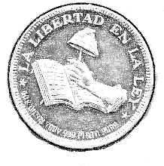
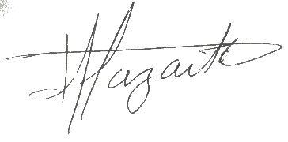
"FREEDOM IN THE LAW"
José Alfredo Loredo Zárate

